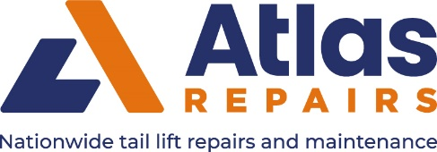

Atlas Repairs ltd. Operate throughout Great Britain and our own engineers can be recognised with the above logo on their Service vans and uniform. Atlas have increased its coverage to match its steady business growth. We are seeking more call centre support staff and tail lift engineers to increase our network still further. Please supply either a CV to info@atlasrepairs.co.uk or for more information complete the brief details in the form below and we will be in contact with you. To discuss any current vacancies.

First Name Surname

Home Post Code

Mobile telephone number Email Address

Your Experience relating to Tail Lift, Double decks, Shutters, winches etc.

